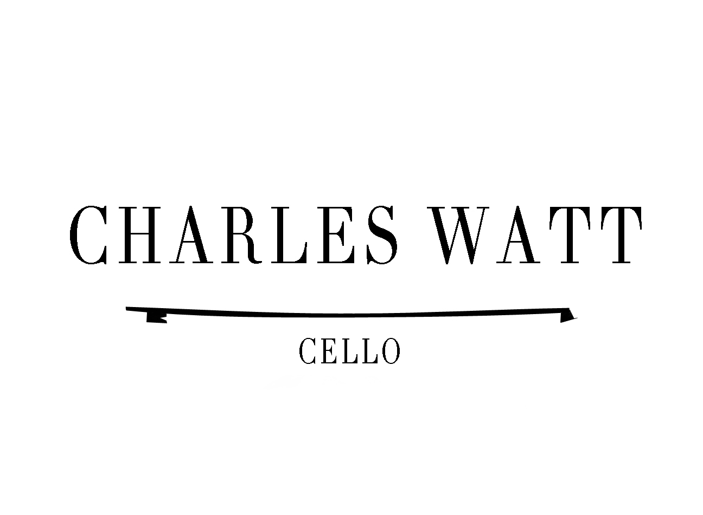

British cellist Charles Watt enjoys a busy schedule combining his passions for symphonic, ensemble and chamber playing with teaching master-classes and giving private lessons.

Based in the Netherlands, Charles started out his career in London having completed studies at Cambridge University and the Guildhall School of Music and Drama. He began teaching the cello and chamber music at an early stage in his career at the world-renowned specialist music schools the Yehudi Menuhin School and the Purcell School. He went on to lead and deliver a pedagogy course at the Guildhall School of Music and Drama.

A multi award-winning instrumentalist in both his capacity as a soloist and chamber musician Charles has won awards and prizes from a number of wonderfully supportive organizations, including the Leverhulme, Vandervelle and Merchant Taylor’s trusts, the Musician’s Benevolent Fund, Making Muusic, Countess of Munster, English Speaking Union, Flame competition, Paris, and the Dutch Classical Talent Competition.

In 2011 Charles moved to Amsterdam to be with his growing family, leaving his posts in London to embark on a freelance career as a performer and teacher.

Since then he has had the pleasure of playing with the gamut of wonderful musicians and ensembles embracing all genres of music from Monteverdi to Louis Andriessen.

Recently Charles has been guest principal with the Rotterdam Philharmonisch Orkest, Amsterdam Sinfonietta and joined ASKO|Schoenberg and Nieuwe Ensemble in a number of tours to China, Craotia, Germany, Wales and Thailand.

